
Lab 1. Install and start the JBoss Data Virtualization Server
There are three different ways to install Red Hat JBoss Data Virtualization.
- Graphical mode: Graphical mode launches a graphical wizard which provides step-by-step instructions for installing and configuring the Red Hat JBoss Data Virtualization. Additional setup, including the Quickstarts and Maven Repository, is also possible with the installer.
- Text mode: You can launch the installer in the text mode as well. Text mode provides step-by-step instructions for installing and configuring the Red Hat JBoss Data Virtualization.
- Automated script mode: You can install multiple identical instances of Red Hat JBoss Data Virtualization using the automated script. This automated script is generated after the first installation instance. We will explain the graphical mode and automated script mode in more detail in the following paragraphs.

1.1 Installing JBoss Data Virtualization through graphical mode
1.1.1 Download the JBoss Data Virtualization installer binary by clicking the green download button at http://www.jboss.org/products/datavirt.html.
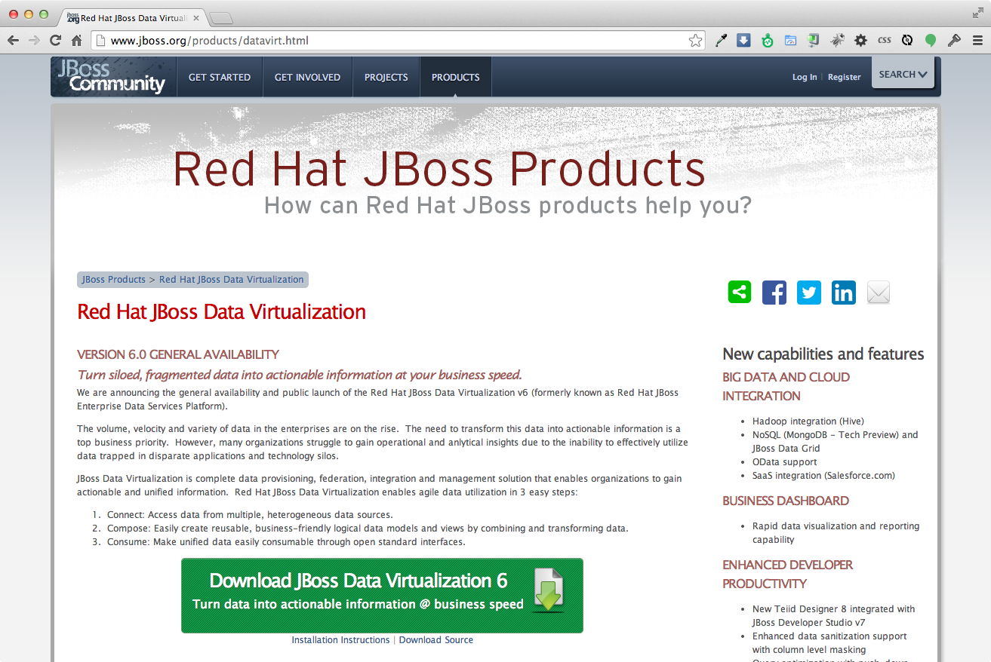

1.1.2 Open a terminal window and navigate to the location where the GUI installer was downloaded.

1.1.3 Run the installer using java at the command prompt:
java -jar jboss-dv-installer-VERSION.jar
The current available version is 6.0.0.GA-redhat-4 and to run the installer at the command prompt see below:
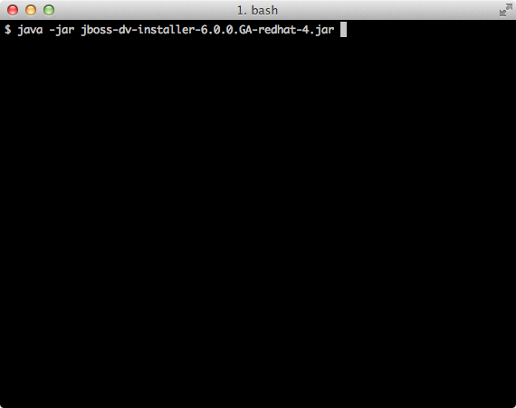

1.1.4 Follow the installer prompts to complete the installation process. See the Getting Started with JBoss Data Virtualization Installation and Configuration video. See http://vimeo.com/76457404) for more details.
A dialogue box will open followed by the End User License Agreement. If you accept the terms of the agreement, click I accept the terms of this license agreement and then click “Next”.
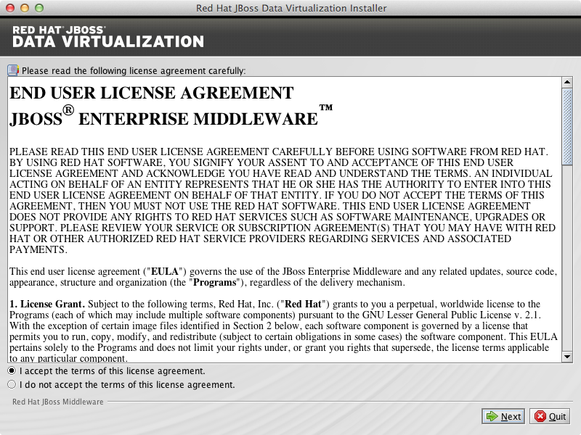

1.1.5 A filepath confirmation dialogue box will appear. In the Select the installation path field, type the path where you want JBoss Data Virtualization to be installed or click Browse to navigate to the desired location. When the Select the installation path field shows the correct path, click “Next”.
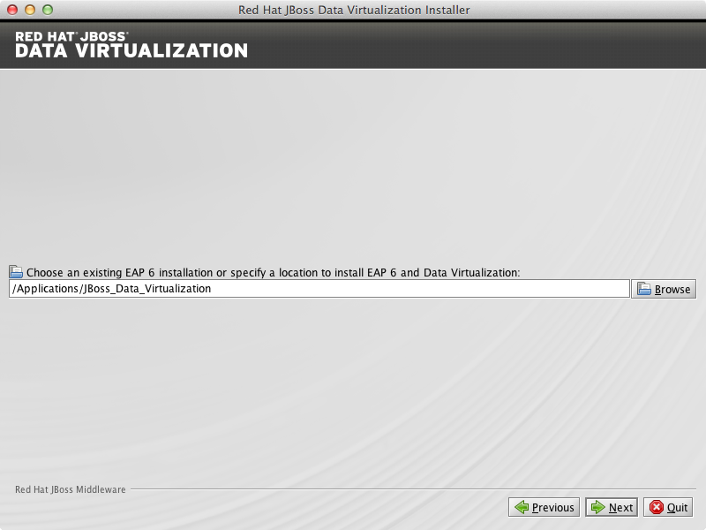

1.1.6 When you are prompted about the specified location being created or overwritten, review the message and, if satisfied, click “OK” and then press “Next”.
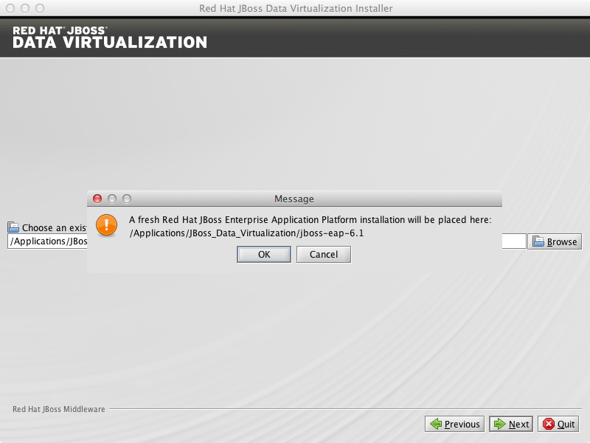

1.1.7 You will be prompted to create a new admin username and password. Once created, it will be added to the ManagementRealm and can be used to access the Management Console and other applications secured using ManagementRealm. Enter the new username and password in the appropriate fields and click “Next”.
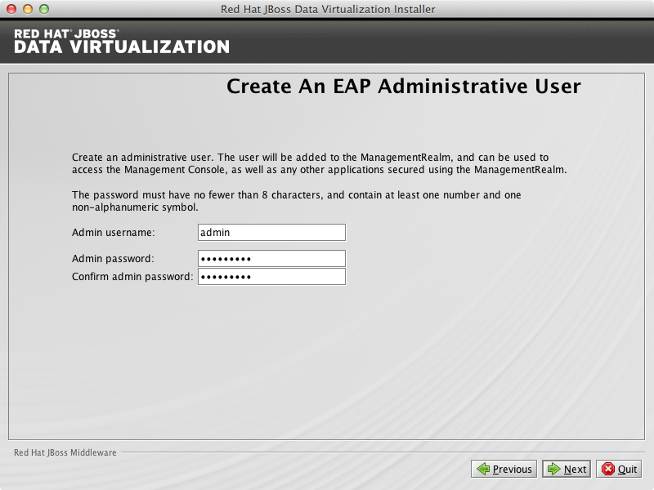

1.1.8 The Maven Repository Setup window appears. You will need to provide Maven repository settings in order to build quickstarts provided in the Red Hat JBoss Data Virtualization installation. At this point, the installer can automatically configure your Maven settings to setup the online repository for remote access.
To setup the Maven repository, select Specify the path (or URL).... Enter the location of the Maven settings.xml file or select Browse to navigate to the file. Alternatively, you can choose to skip the Maven repository setup.
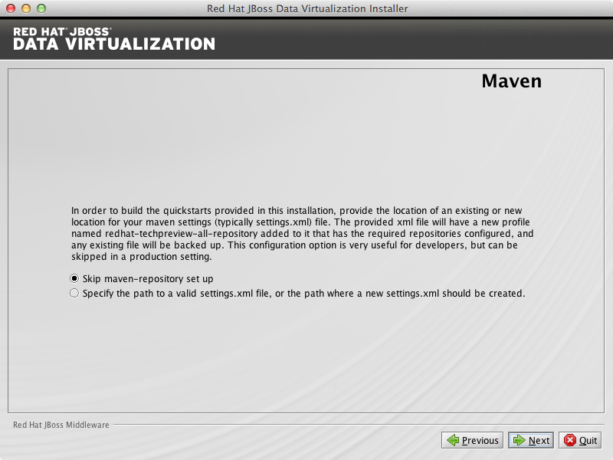
Skip maven-repository set up for now. Click “Next” to proceed.

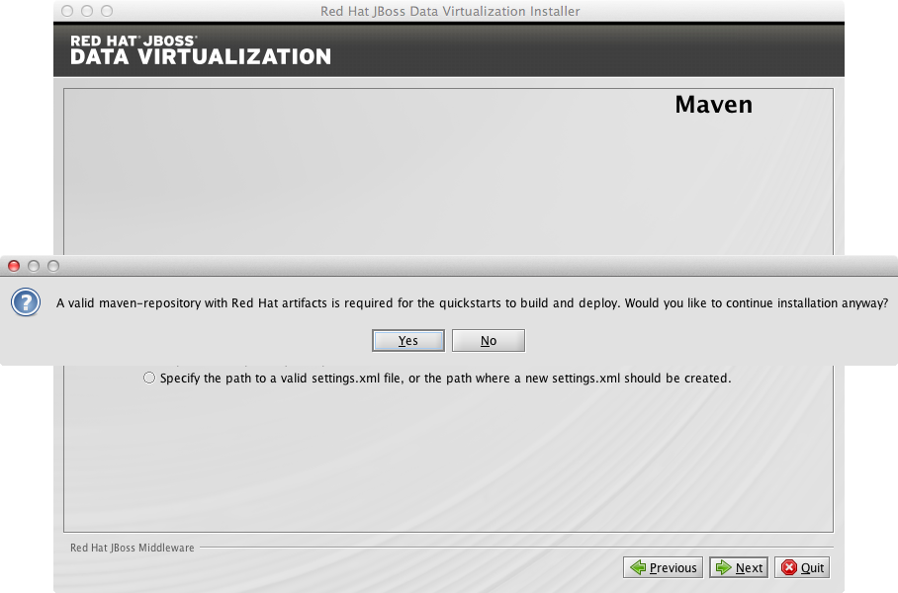
Click “Yes” to proceed.

1.1.9 You can install JBoss Data Virtualization either with default configuration or with additional configuration options. Select option Perform default configuration. Click “Next” to proceed.
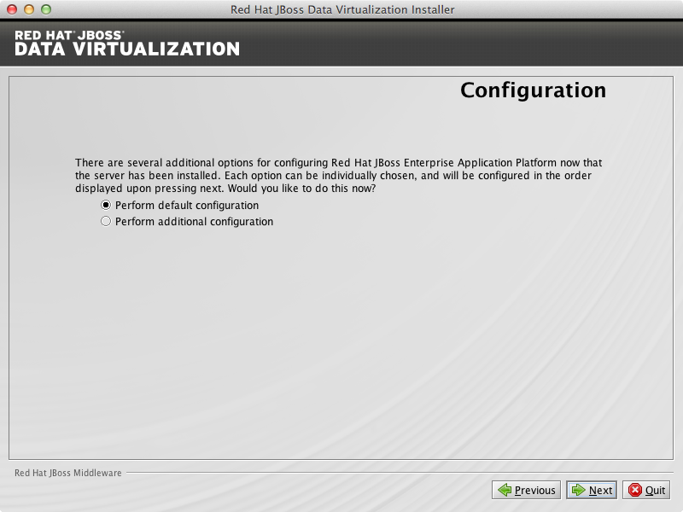

1.1.10 A summary of the installation will be displayed. Click “Next” for the installation to commence. This may take a minute.
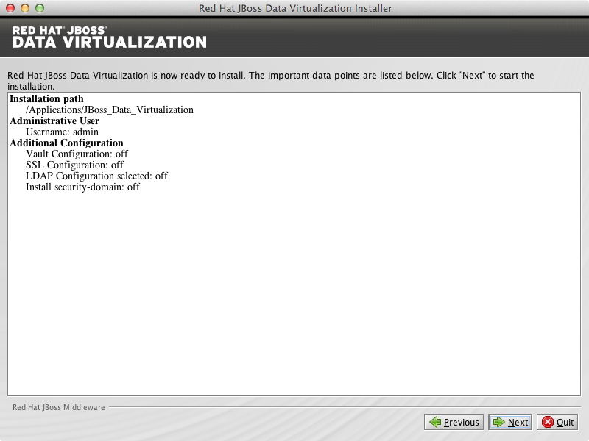

Once all the components are installed, click “Next”.
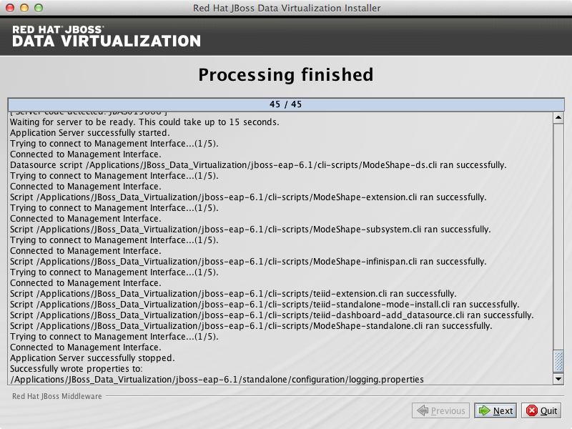

Click Generate installation script and properties file if you wish to generate an automatic script and properties file.
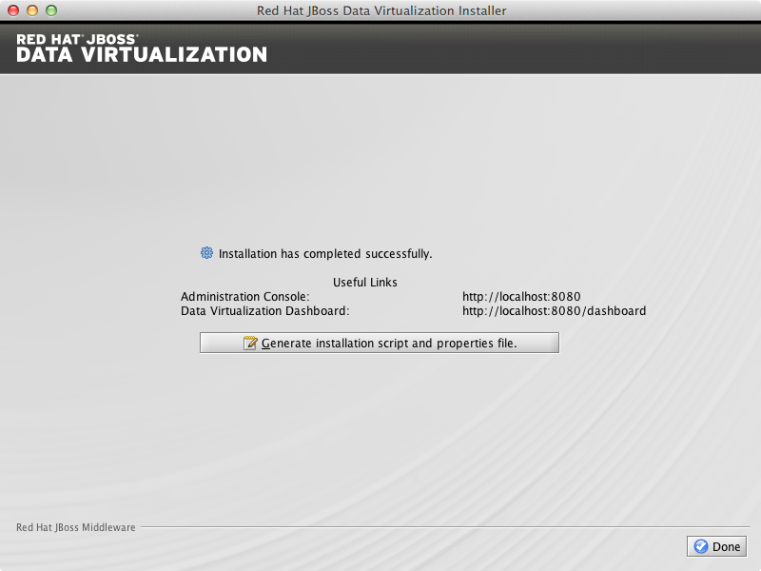
For now click “Done” to complete the installation.

1.1.11. Red Hat JBoss Data Virtualization is now successfully installed and configured.
When the installation is complete, navigate to
- Unix/Linux: EAP_HOME/bin and run the ./standalone.sh
- Windows: EAP_HOME\bin and run standalone.bat
to start the JBoss Data Virtualization server.

1.2 Installing JBoss Data Virtualization through automated script mode
Installing JBoss Data Virtualization by using an automated script provides everything you need to get you started quickly.
1.2.1 Clone the repository from https://github.com/kpeeples/simplified-dv-template.git
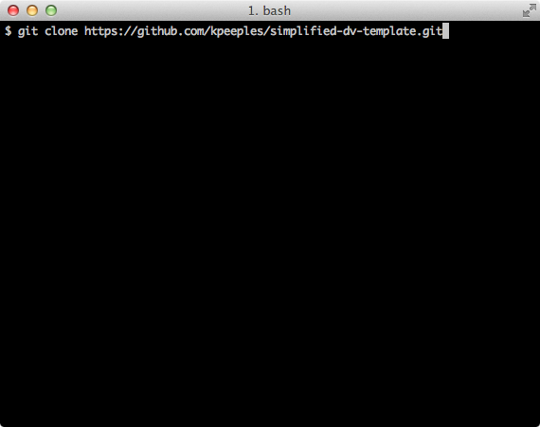

The following username/passwords will be installed automatically for access to
JBoss EAP Administration console: admin/redhat1!
Teiid Server: user/user

1.2.2 Download the JBoss Data Virtualization installer binary by clicking the green download button at http://www.jboss.org/products/datavirt.html
1.2.3 Place the software in the distros subfolder of simplified-dv-template folder which was previously created in step 1.2.1.

1.2.4 Modify the support/InstallationScript.xml file to contain the full path to the installed/dv directory. Make sure to leave the installed/dv directory. The script performs the automated install of Jboss Data Virtualization v6.0.0.GA.
<installpath>/home/kpeeples/demos/dv-install-script-demo/installed/dv</installpath>

1.2.5 Run the install-run.sh script to install JBoss Data Virtualization and the server will be started automatically as shown below.
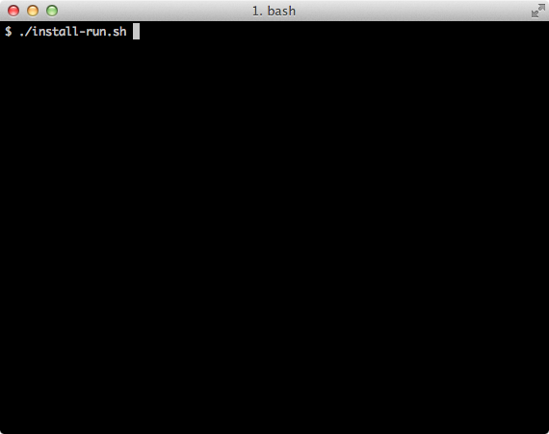

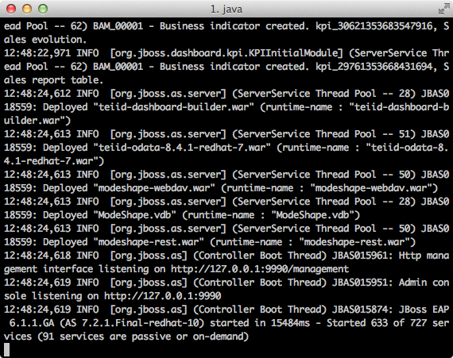

1.2.6 Change the password of the admin user which will be used at a later stage
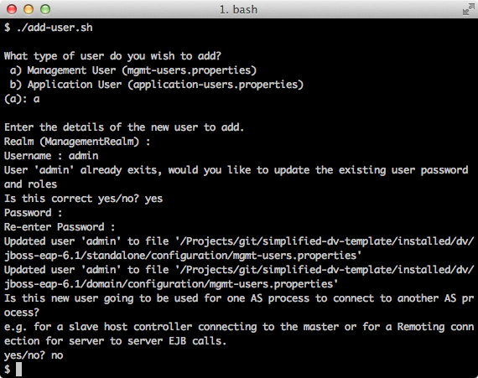
Go to the subfolder installed/dv/jboss-eap-6.1/bin of simplified-dv-template folder which was previously created in step 1.2.1 and type in the following command and inputs as shown below.

1.2.7 Browse to http://localhost:8080/dashboard for the Red Hat JBoss Data Virtualization Dashboard to verify the installation and use user/user as the credentials that were installed as default and click “Log In”.
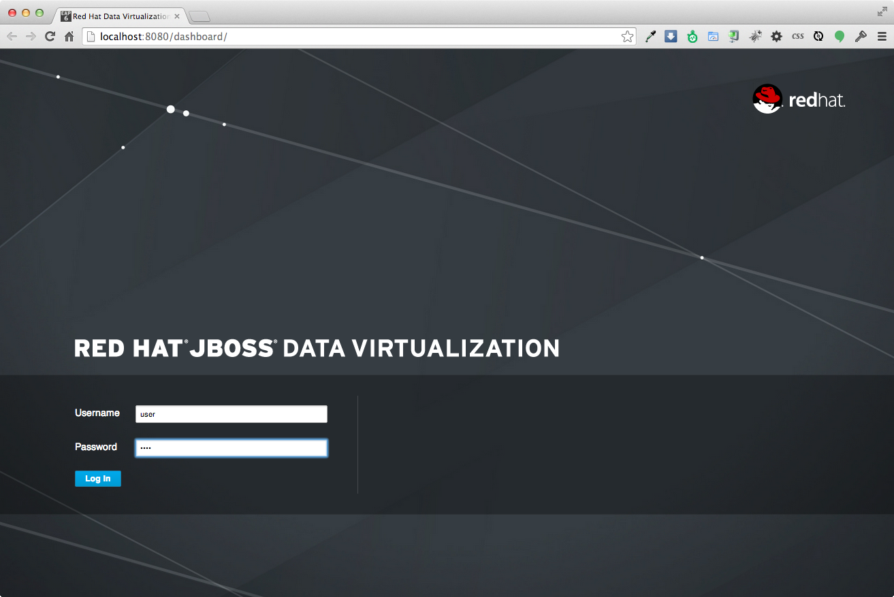
JBoss Data Virtualization is now successfully installed, configured and started using the automated script mode.

1.3 Provision JBoss Virtualization on OpenShift online
With OpenShift you can easily deploy and run JBoss Data Virtualization in minutes to connect your applications to data from many different sources. JBoss Data Virtualization on OpenShift Online is available as a Developer Preview to allow you to explore the capabilities of the technology running on OpenShift Online.
1.3.1 Get your free OpenShift Online account
Sign up for your free account OpenShift Online account at https://www.openshift.com/app/account/new and you should see the screen below.
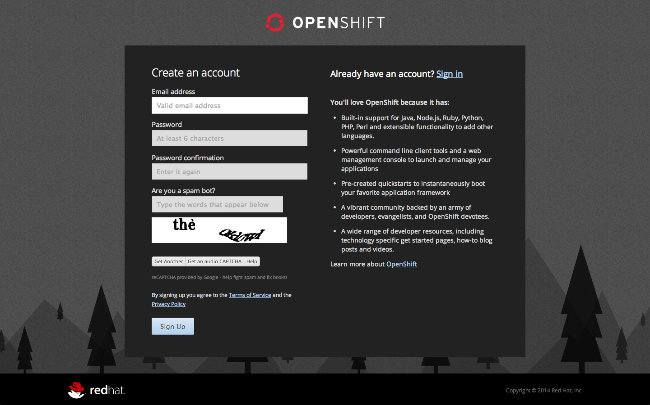
If you already have an OpenShift Online account please sign in with your known OpenShift Online username password combination.

1.3.2 Create a new application
If this is your first login into OpenShift Online click at the “-> Create your first application now” link
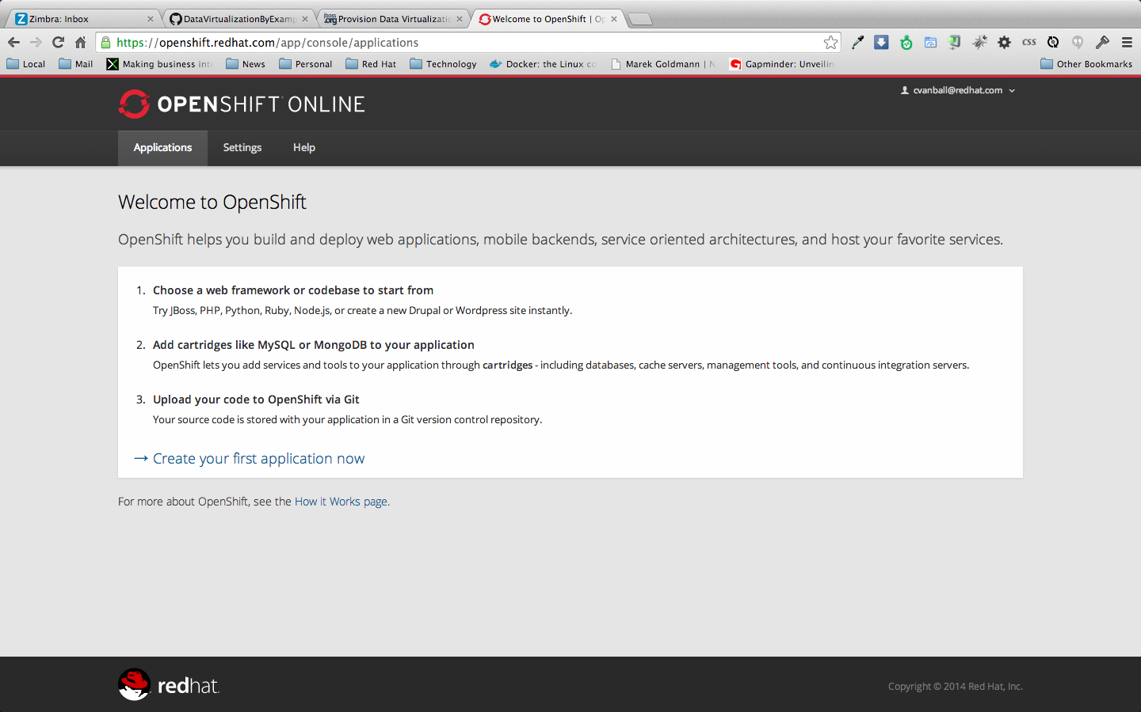
If you already have an OpenShift Online account click the “Add Application” button below your list of applications.
Alternately, you can deploy the DataVirtualization cartridge using the OpenShift RHC Client Tools. Using the rhc client tools type:
$ rhc app create dv jboss-dv-6.0.0

1.3.3 Choose a type of applications
You can either scroll down to the list of quick links and click “JBoss Data Virtualization 6” under “xPaaS” or search for “Data”.
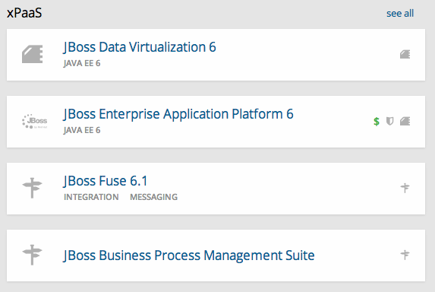

or
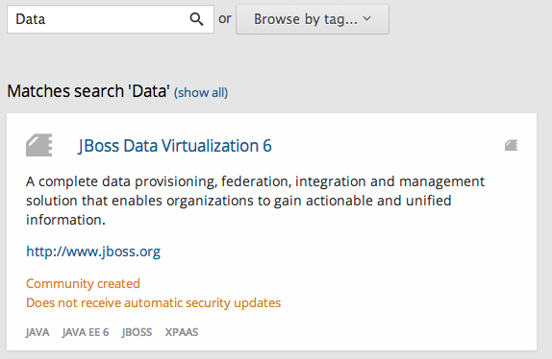

Click “JBoss Data Virtualization 6”

1.3.4 Configure Application
Name your application in your domain, scroll down and click “Create Application” button.
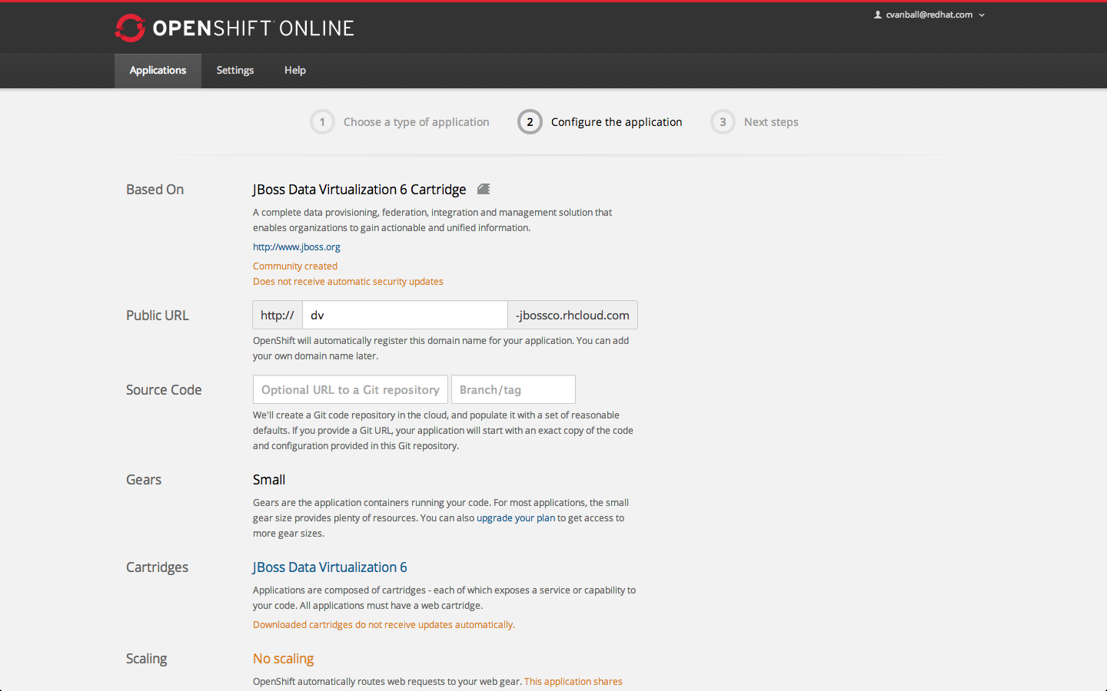

1.3.5 Next steps
In the Next steps we would like a PostgreSQL database to the application previously created on OpenShift Online.
The following figure is shown when the application is successfully created in your domain.
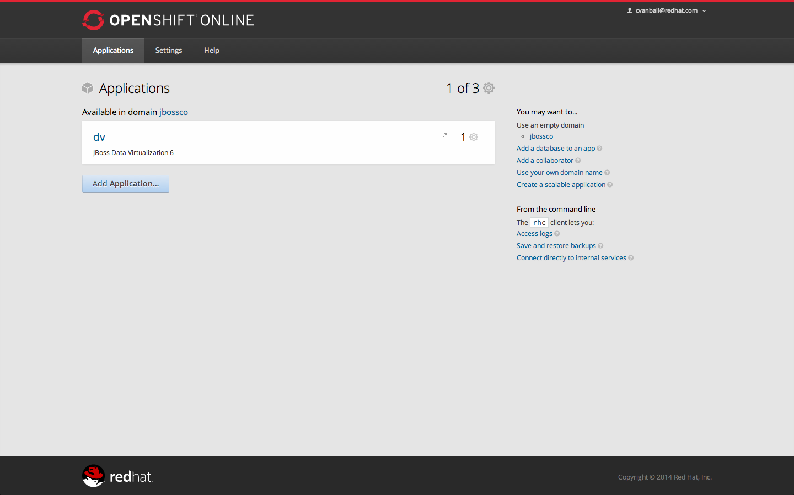
Now we would like to add a PostgreSQL database to the application. Click the Application name link, in the above figure it's called “dv”.

The following screen should appear.
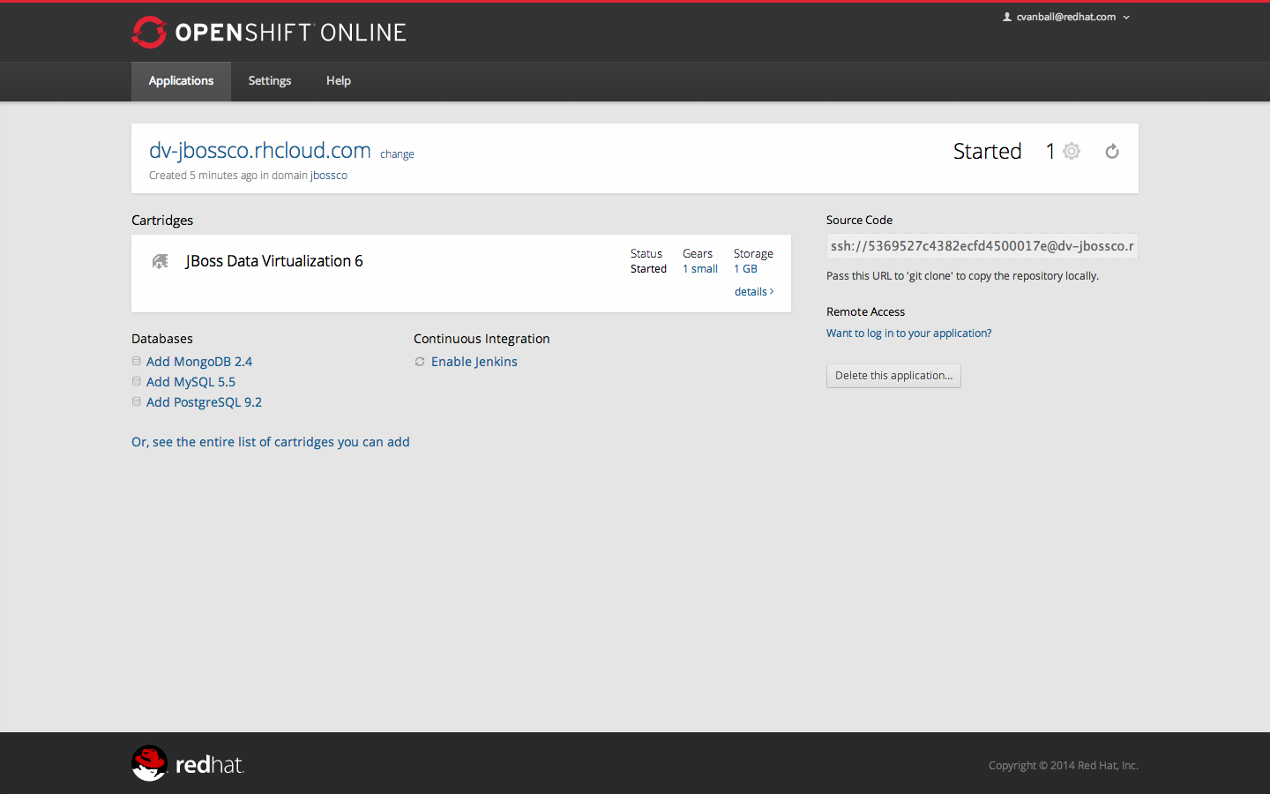
Click “Add PostgreSQL 9.2” and click at the next appearing screen “Add Cartridge”.
You have now a successfully created a JBoss Data Virtualization environment with a PostgreSQL 9.2 database in just a matter of seconds.

Note: at the moment you need a local installation of JBoss Data Virtualization in order to deploy Data Virtualization projects to the OpenShift environment. This will be addressed in a newer version of JBoss Developer Studio.

Congratulations, you have completed Lab #1.

